Logistics for the 2025 World Languages Fair
October 18th, 2025

Arrival & Parking
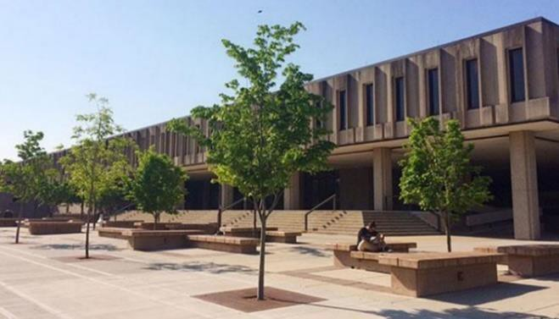
The main portion of the event will be held on the 4th floor of Wescoe Hall, which is located at 1445 Jayhawk Boulevard. A picture is provided to the right, and there is a large sign outside the building.
The easiest way to navigate to Wescoe Hall is through the main campus entrance at the corner of Iowa Street (US-59) and 15th Street (Bob Billings Pkwy). Schools transporting students to the event in buses may drop students off on Jayhawk Boulevard in front of Wescoe Hall. Normal KU buses will also be running on the day of the event, so you should be prepared to unload quickly. Buses can then proceed to free, long-term parking in lot 90 on the east side of Naismith Drive in front of the Rec Center. Those arriving in passenger cars and vans may park for free in lots 36 and 39 along Memorial Drive. Parking lots can be viewed in more detail on the KU Lawrence Campus map.
Wescoe Hall

Check-In (9:30 AM – 9:55 AM)
The check-In desk for the event will be under the overhang at the front of Wescoe Hall (see above).
Event packets will be organized by school and will include a name badge, a schedule of presentations, and a World Languages Fair passport for each student. Teachers and chaperones will each receive a name badge, presentation descriptions, a schedule of presentations, and a copy of this document.
Teachers and chaperones are welcome at this time, or at any time during the day, to grab a coffee in the Teachers’ Lounge just inside Wescoe 4070. There will also be a Mother’s Room available inside Wescoe 4070c.

World Languages Fair (WLF) Passport

Each presentation in the program is marked with the world region(s) that it covers – Africa (AF), the Americas (AM), East Asia (EA), Eastern Europe & Eurasia (EE), or Western Europe (WE). At the end of each presentation, the instructor will punch the corresponding world region on the student’s WLF passport. Students can only get one world region punched per presentation, so they will need to choose their presentations carefully if they wish to maximize their number of punches. At the end of the day students will receive one raffle ticket for each world region punched on their passport, so the more varied the presentations they attend, the better their chances are at winning a prize!

Welcome Session and Alumni Panel (10:00 AM – 11:00 AM)
The welcome session and the alumni panel will be held in 3139 Wescoe Hall, which is next to the check-in desk. The welcome session will provide a brief introduction to the World Languages Fair and orient students to the events of the day. The alumni panel will host KU and KSU alumni discussing how knowing a foreign language has led to diverse and exciting professional opportunities. Students will be able to ask questions to the panelists.

Presentation Sessions (11:20 AM – 11:50 AM, 1:00 PM – 2:50 PM)
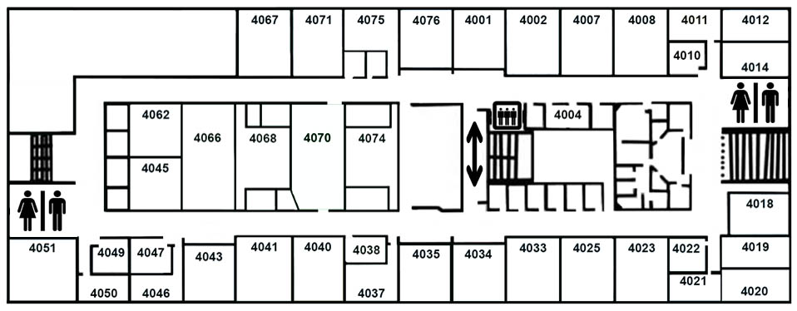
All presentations will take place on the 4th floor of Wescoe Hall. To reach the 4th floor from 3139 Wescoe use the internal staircase or the elevator in the main building. OLRC staff will be available to provide directions after the welcome session.

Lunch (11:50 AM – 12:50 PM)
Lunch and the Information Fair will take place simultaneously on the 4th floor of Wescoe Hall during the midday break. All participants will be provided with a boxed lunch with a drink that they can eat picnic-style in the hallway or take into a classroom to eat with their group. There will be a separate designated table for those who requested a special meal to meet dietary restrictions.
There will be language brochures from participating institutions available outside of 4070 Wescoe (KU) and inside of 4066 Wescoe (all others). Students might want to use the lunch hour to talk to presenters and to get information about language study, scholarships, and study abroad opportunities.

Closing Session and Raffle (3:00 PM – 3:30 PM)
The day will conclude with a final gathering in 3139 Wescoe, the same location as the morning’s welcome session. Students will present their WLF Passport to designated staff, who will award a raffle ticket for each world region punched. Students must be present to win.

Departure
Buses should pick up students on Jayhawk Boulevard in front of Wescoe Hall or Budig Hall. Please keep in mind that all schools will be departing simultaneously, and traffic is likely to be heavy.

