Logistics for the 2022 World Languages Fair

Arrival & Parking
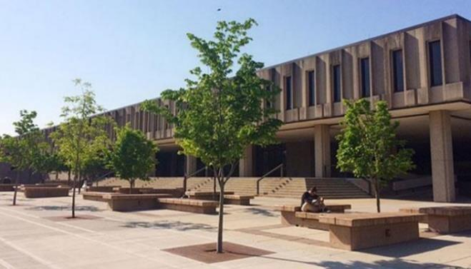
The main portion of the event will be held on the 4th floor of Wescoe Hall, which is located at 1445 Jayhawk Boulevard. A picture is provided to the right, and there is a large sign outside the building.
The easiest way to navigate to Wescoe Hall is through the main campus entrance at the corner of Iowa Street (US-59) and 15th Street. Schools transporting students to the event in buses may drop students off on Jayhawk Boulevard in front of Wescoe Hall. Normal KU buses will also be running on the day of the event, so you should be prepared to unload quickly. Buses can then proceed to free, long-term parking in lot 90 to the east of Naismith Drive in front of the Rec Center. Those arriving in passenger cars and vans may park for free in lots 36 and 39 along Memorial Drive. Parking lots can be viewed in more detail on the KU Lawrence Campus map.

Check-In (9:30 AM – 9:55 AM)
The Check-In desk for the event is in 4070 Wescoe Hall, which is located on the fourth (and top) floor of the building. To reach Room 4070, there are external staircases on either end of the building and an internal staircase in the middle of the building. There is an accessible entrance provided on the east side of Wescoe, with the elevator midway down the main hall on the left. The ground floor of the building is the 3rd floor, so the 4th floor of Wescoe is just one floor up.
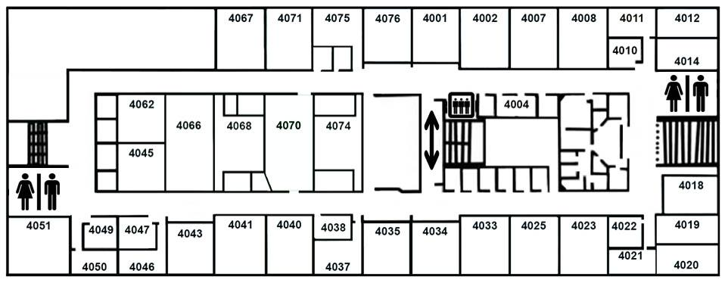
Event packets will be organized by school or group and will include a name badge, an event program, and a World Languages Fair Passport for each student participant (detailed below). Teachers and chaperones will receive a name badge, an event program, and a copy of this document.
Teachers and chaperones are welcome at this time, or at any time during the day, to grab a coffee in the Teachers’ Lounge just inside of Wescoe 4070. There will also be a Mother’s Room available, with a minifridge for storage, inside of Wescoe 4070.

World Languages Fair (WLF) Passport
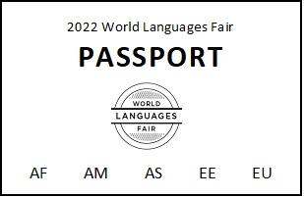
Each presentation in the program is marked with the world area(s) which it covers – Africa (AF), the Americas (AM), East Asia (EA), Eastern Europe & Eurasia (EE), and Western Europe (EU). At the end of each session, the presentation leader will punch out the associated world area(s) on the student’s World Languages Fair (WLF) Passport. Students only get one world area punched per session, so they will need to choose their presentations carefully to vary which world regions their chosen sessions cover. Students will receive one raffle ticket at the end of the day for each world area punched on their passport, so the more varied the sessions they attend, the better their chances at winning a raffle prize!

Welcome Session (10:00 AM – 10:20 AM)
The welcome session will be in 3140 Wescoe Hall, which is one of two auditoriums in Wescoe Hall facing Jayhawk Boulevard. We will have staff available to escort groups from the check-in desk
to the welcome session, as needed.
The welcome session will provide a brief introduction to the World Languages Fair and orient students on the events of the day. There will be staff available in 4070 Wescoe Hall during the welcome session for any late arrivals.

Morning Sessions (10:30 AM – 11:40 AM)
Students will have the opportunity to choose two 30-minute sessions held in classrooms on the 4th floor of Wescoe Hall. There will be approximately 12-14 different sessions running simultaneously between 10:30 AM – 11:00 AM and 11:10 AM – 11:40 AM. While students are free to choose whichever sessions appeal to them, they are encouraged to attend sessions about languages and areas of the world with which they are less familiar.

Lunch & Information Fair (11:50 AM – 12:50 PM)
Lunch and the Information Fair will take place simultaneously on the 4th floor of Wescoe Hall during the mid-day break. All participants will be provided a boxed lunch containing a sandwich, fruit snacks, chips, a cookie, and a drink which they can then eat picnic-style in the hallway or take into a classroom to eat with their group.
At the same time, there will be an Information Fair about language-related scholarships and study abroad opportunities at Fort Hays State University, Johnson County Community College, Kansas State University, Missouri State University, Pittsburg State University, and the University of Kansas for students to peruse. The information fair will also be held in the hallways of the 4th floor of Wescoe Hall.

Afternoon Sessions (1:10 PM – 2:50 PM)
There will be three, 30-minute afternoon sessions running between 1:00 PM – 1:30 PM, 1:40 PM – 2:10 PM, and 2:20 PM – 2:50 PM on the 4th floor of Wescoe Hall.

Closing Session and Raffle (3:00 PM – 3:30 PM)
The World Languages Fair will conclude with a final gathering in 3140 Wescoe, the same auditorium as the morning’s Welcome Session. As students arrive, they will present their WLF Passport to designated staff who will provide them with the raffle tickets earned for each world area punched on their passport. The raffle will take place after some brief comments from the event sponsors, and winners must be present to take home a prize.

Departure
Buses may pick up students on Jayhawk Boulevard in front of Wescoe Hall. Please keep in mind that all schools will be departing simultaneously, and traffic is likely to be heavy.

World Languages Fair Schedule
Saturday, October 29, 2022

TIME | EVENT
9:30 AM – 9:55 AM | Registration  Wescoe Hall, Room 4070
10:00 AM – 10:20 AM | Welcome Session  Wescoe Auditorium, Room 3140
10:30 AM – 11:00 AM | Session 1  Wescoe Hall, 4th Floor
11:10 AM – 11:40 PM | Session 2  Wescoe Hall, 4th Floor
11:50 AM – 12:50 PM | Lunch & Information Fair  Wescoe Hall, 4th Floor
1:00 PM – 1:30 PM | Session 3  Wescoe Hall, 4th Floor
1:40 PM – 2:10 PM | Session 4  Wescoe Hall, 4th Floor
2:20 PM – 2:50 PM | Session 5  Wescoe Hall, 4th Floor
3:00 PM – 3:30 PM | Closing Session & Raffle  Wescoe Auditorium, Room 3140

