Ordnen Sie die Bilder den Berufen zu:

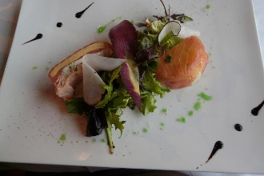  _________________ | 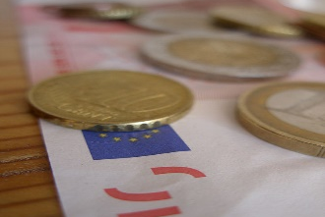  _________________ | 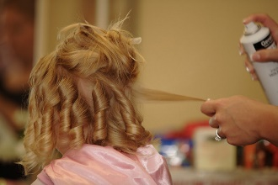  _________________ | 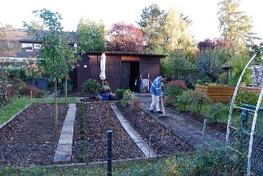  _________________
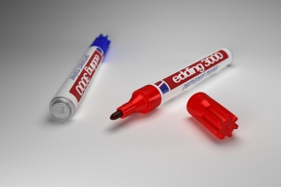  _________________ | 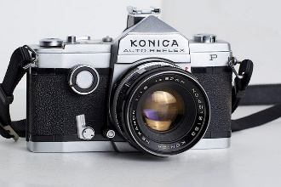  _________________ | 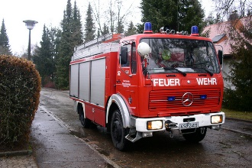  _________________ | 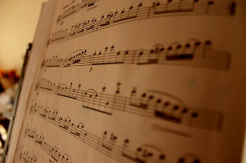  _________________
 | 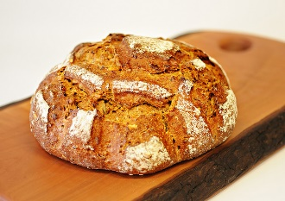  _________________ | 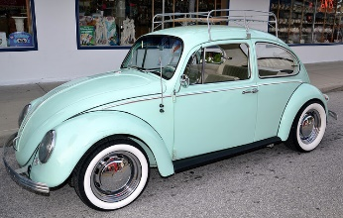  _________________

der Automechaniker | die Bankkauffrau | der Bäcker | der Friseur | die Lehrerin
der Feuerwehrmann | der Gärtner | die Fotografin | der Musiker | die Köchin

Ordnen Sie die Berufe den Berühmtheiten zu:

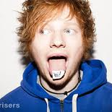  ____________________ | 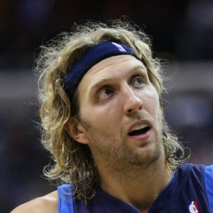  ____________________ | 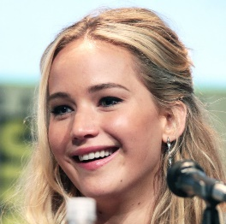  ____________________ | 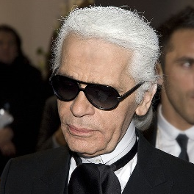  ____________________
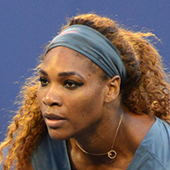  ____________________ | 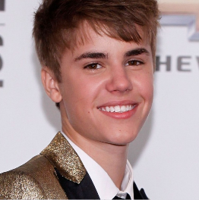  ____________________ | 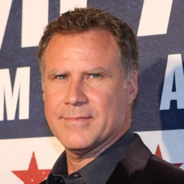  ____________________ | 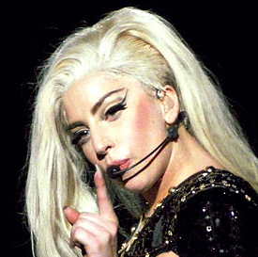  ____________________
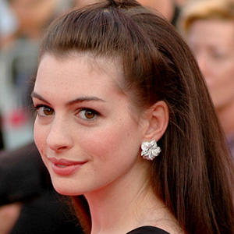  ____________________ | 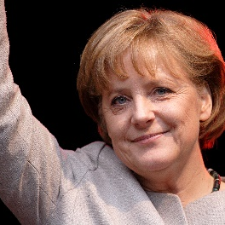  ____________________ | 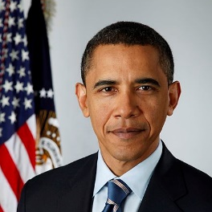  ____________________ | 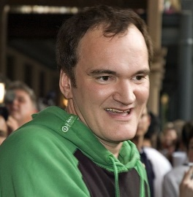  ____________________
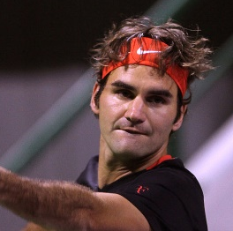  ____________________ | 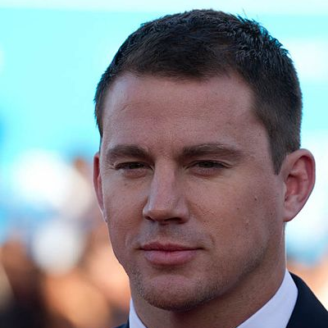  ____________________ | 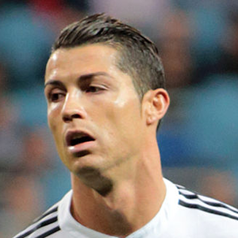  ____________________ | 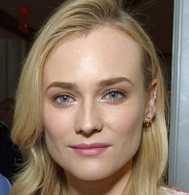  ____________________

Sänger | Sängerin | Politiker | Politikerin
Schauspieler | Schauspielerin | Tennisspieler | Tennisspielerin
Produzent | Fußballspieler | Basketballspieler | Designer

2017 by Schirin Kourehpaz under a Creative Commons Attribution 4.0 International License.

- “Markers” by Daniel Dionne is licensed under CC BY–SA 2.0. https://www.flickr.com/photos/mrzeon/4540233331. Last accessed July 14, 2017.
- “Man sieht, was es ist by tlegeltuf” is licensed under CC BY–SA 2.0.
https://www.flickr.com/photos/11596438@N00/13145015573. Last accessed July 14, 2017.
- “Noten” by philippflenker is licensed under CC BY 2.0.
https://www.flickr.com/photos/pjaquet/7992148771. Last accessed July 14, 2017.
- “PICT0011” by Jürgen L. Baumann is licensed under CC BY–ND 2.0.
https://www.flickr.com/photos/jubasoft/6874309506. Last accessed July 14, 2017.
- “Französische Küche” by sanfamedia.com is licensed under CC BY-ND 2.0.
https://www.flickr.com/photos/kudo88/10367771076. Last accessed July 14, 2017.
- “DSC_0074_pp” by Walter is licensed under CC BY 2.0.
https://www.flickr.com/photos/walterpro/14755923599. Last accessed July 14, 2017.
- “Hair Salon” by Ray Dumas is licensed under CC BY-SA 2.0.
https://www.flickr.com/photos/rtdphotography/3630856554. Last accessed July 14, 2017.
- ‘Camera” by Juan Barrios is licensed under CC BY-ND 2.0.
https://www.flickr.com/photos/jmbarrios/5717007837. Last accessed July 14, 2017.
- “Euros” by Robert Brook is in the public domain.
https://www.flickr.com/photos/brook/32386362. Last accessed July 14, 2017.
- “Garten” by Ting Chen is licensed under CC BY-SA 2.0.
https://www.flickr.com/photos/philopp/4082807686. Last accessed July 14, 2017.

- “Ronaldo vs. FC Schalke 04 (16854146922, cropped).jpg” by Chris Deahr is licensed under CC BY-SA 2.0.
https://commons.wikimedia.org/wiki/File:Ronaldo_vs._FC_Schalke_04_(16854146922,_cropped).jpg. Last accessed July 12, 2017.
- “Anne Hathaway Face.jpg” by Mireille Ampilhac is licensed under CC BY-SA 3.0. https://commons.wikimedia.org/wiki/File:Anne_Hathaway_Face.jpg. Last accessed July 12, 2017.
- “Ed Sheeran Performs On Walmart Soundcheck Risers” by Lunchbox LP is licensed under CC BY 2.0.
https://www.flickr.com/photos/lunchboxstudios/8366036110. Last accessed July 14, 2017.
- “Dirk Nowitzki” by Keith Allison is licensed under CC BY-SA 2.0.
https://www.flickr.com/photos/keithallison/3997657524. Last accessed July 14, 2017.
- “Jennifer Lawrence” by Gage Skidmore is licensed under CC BY-SA 2.0.
https://www.flickr.com/photos/gageskidmore/19468446940. Last accessed July 14, 2017.
- “Karl Lagerfeld Berlinale 2008.jpg” by By Siebbi is licensed under CC BY 3.0.
https://upload.wikimedia.org/wikipedia/commons/6/60/Karl_Lagerfeld_Berlinale_2008.jpg. Last accessed July 14, 2017.
- “Serena Williams” by Edwin Martinez is licensed under CC BY 2.0. https://en.wikipedia.org/wiki/Serena_Williams#/media/File:Serena_Williams_at_2013_US_Open.jpg. Last accessed July 17, 2017.
- “Angela Merkel” by א (Aleph) is licensed under CC BY-SA 2.5.
https://commons.wikimedia.org/wiki/File%3AAngela_Merkel_(2008).jpg. Last accessed July 17, 2017.
- “Justin Bieber Billboard Music Awards 2011-12” by IloveJB123 is licensed under CC BY 2.0.
https://www.flickr.com/photos/67926342@N08/6175343447. Last accessed July 17, 2017.
- “Official portrait of Barack Obama.jpg” by Pete Souza is licensed under CC BY 3.0.
https://commons.wikimedia.org/wiki/File:Official_portrait_of_Barack_Obama.jpg. Last accessed July 17, 2017.
- “Quentin Tarantino retouched.jpg” by Jeff Balke (retouched by Dany3000) is licensed under CC-BY-SA-3.0.
https://commons.wikimedia.org/wiki/File:Quentin_Tarantino_retouched.jpg. Last accessed July 17, 2017.
- “Roger Federer Doha.jpg” by Vinod Divakaran is licensed under CC BY 2.0.
https://commons.wikimedia.org/wiki/File:Roger_Federer_Doha.jpg. Last accessed July 17, 2017.
- “Lady Gaga BTW Ball Antwerp 02.jpg” by Yne Van De Mergel is licensed under CC BY 2.0.
https://commons.wikimedia.org/wiki/File%3ALady_Gaga_BTW_Ball_Antwerp_02.jpg. Last accessed July 17, 2017.
- “Diane Kruger Peabody 2014 (cropped).jpg” by Peabody Awards is licensed under CC BY 2.0.
https://commons.wikimedia.org/wiki/File%3ADiane_Kruger_Peabody_2014_(cropped).jpg. Last accessed July 17, 2017.
- “Channing Tatum (9686615052).jpg” by Isabelle Veronese is licensed under CC BY-SA 2.0.
https://commons.wikimedia.org/wiki/File%3AChanning_Tatum_(9686615052).jpg. Last accessed July 17, 2017.
- “Will Ferrell 2012.jpg” by Eva Rinaldi is licensed under CC BY-SA 2.0.
https://commons.wikimedia.org/wiki/File%3AWill_Ferrell_2012.jpg. Last accessed July17, 2017.

